УТВЕРЖДАЮ
Директор МБОУ “Лицей №188”
Э.Г. Расулова
Приказ №______ от __________

Промежуточная аттестация по английскому языку за курс 5 класса

Вариант 1
1.Match the words.(Score: ___/8)
- School a) TV
- Watch b) to bed
- Information c) breakfast
- Have d) homework
- Bottle e) bag
- Do f) flowers
- Plant g) of lemonade
- Go h) technology
2. Underline the correct word.(Score: ___/4)

1) Ann is so beautiful! Her / she / my eyes are big and blue.
2) Look at the girl. What’s her/ your / his name?
3) This is my father. Look at he / him / her.
4) Can your/ you / yours swim?

3. Fill in a, an or some.(Score: ___/5)
- ______ lemon
- ______ orange juice
- ______ rice
- ______ onion
- _______ bananas

4. Write the plurals. (Score: ___/5)
1) boy- __________2) fox- __________3)bus- ___________4)child - ___________5)tomato - _____________

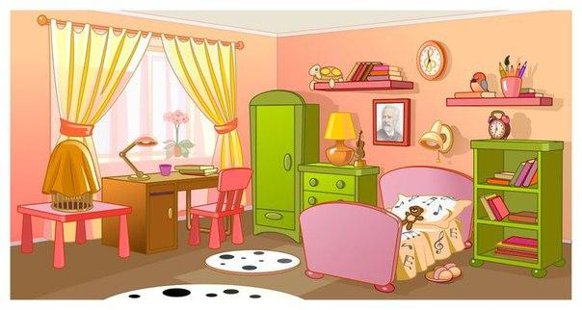
6. Look at the picture. (Score: ___/5)
Fill in: on, in, next to, in front of.
1) The picture is _____________the wall.
2) The table is _____________the window.
3) The carpet is ________ the floor.
4) The bed is_____________the bookcase.
5) There is a wardrobe ___________ the room.

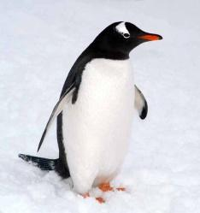
7. Read the text and mark the sentences T (true), F (false) or DS (doesn’t say). (Score: ___/5)
This is a picture of a penguin. A penguin is a bird. Penguins can’t fly. They live in the Antarctic. Penguins are so fat! The penguin is black and white. Penguins don’t sleep during the day. They sleep at night. They swim fast and catch food in the sea. They eat small fish and can stay under the water for five minutes.
- A penguin is a domestic animal. ______
- It can’t swim.____
- Some penguins are yellow._______
- Penguins eat fish._____
- They can stay under the water for five minutes. ______

